

Title: MaineDOT Guidelines on Crosswalks Discipline: General Engineering

Originators: Stephen Landry and Regional Traffic Engineers

Approved By: Joyce Taylor, P.E.,
Chief Engineer

Issue Date: March 6, 2013
Revised Date: March 14, 2013 Revison#2 Date: October 13,2016 Revision#3 Date: November 28, 2016
Revision #4 Date: April 16, 2019
Revision #5 Date: August, 28, 2020
Revision#6 Date: July 6, 2021
Revision#7 Date: July 10, 2025

Background
Crosswalks are marked areas where pedestrians can safely cross a roadway. By law in the State of Maine (Title 29-A Subsection 2056-4) any vehicle must yield the right-of-way to a pedestrian who has entered a marked crosswalk when a traffic control device is not in operation. This law makes it imperative that crosswalk placement, markings and usage be done in a uniform way.
Technical Guidance
The Sections below will offer guidance to the designer on crosswalk criteria. The first three sections have mandatory requirements from ADA, MUTCD and required Safety requirements. The last section contains miscellaneous safety instructions for the designer to strive for. The State Traffic Engineer and Program Managers can sign off on any changes to the miscellaneous safety section. (See Table 3 for additional information.)

Section 1: ADA (Required)

- All crosswalks shall meet the criteria put forth in the American’s with Disabilities Act (ADA), 49 CFR 37, Appendix A and will be built to MaineDOT standard details for pedestrian ramps 801(11) – 801(27) and details for detectable warning placement 608(02)

Section 2: MUTCD (Required)

- No parking shall be allowed within 20 feet of any un-signalized crosswalk (includes mid-block) and 30 feet at a signalized intersection. Signs should be installed indicating that no parking is allowed. (see Figure 1). Option - Parking restrictions can be removed when bump-outs or curb extensions are built. Bump-outs/curb extensions allow the pedestrian to be seen by the traveling public.

- All crosswalks shall meet the latest Manual on Uniform Traffic Control Devices (MUTCD) Section 3C Crosswalk markings. They shall be a minimum of six (6) feet wide (Minimum crosswalk width shall be 8 feet where the posted speed limit is 40 mph or greater at a non-intersection crosswalk.) and marked with white paint as shown on the attached sheet Figure 2. Crosswalks shall be painted at least annually and shall be retro-reflective for nighttime visibility. Crosswalks should be lighted for nighttime use. For added visibility, the zebra (diagonal style markings) or the Continental (piano key style marking) should be used. Option: A municipality may choose to use a painted infill design in its crosswalks. The infill design shall not be retro-reflective and shall not be used on crossings with a posted speed greater than 25 mph. Painted surfaces have a lower coefficient of friction and can impact stopping distances, areas should be well thought out for potential impacts to pedestrians. MaineDOT recommends temporary chalk paint for these types of undertakings. Three dimensional (3D) crosswalks and word messaging within the crosswalk are not allowed as options. The following items are not allowed as infill design:
  - Material that demeans or disparages an individual or group of individuals
  - Material that contains an image or description of graphic violence
  - Material that promotes or encourages unlawful or illegal behavior or activities
  - Material with obscenity or images of nudity
  - Material describing, depicting, or representing sexual activities or human anatomy in a way that the average adult, with contemporary community standards, would find appealing to the prurient interest of minors and adults in sex.

- Crosswalks shall have the appropriate signage (W11-2 and S1-1 series from the
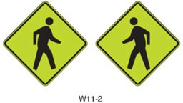
Manual on Uniform Traffic Control Devices, see section 9C.08 and 7B-
.02 of the MUTCD). These signs shall be black symbol on yellow background or black symbol on fluorescent yellow-green background. Signs of different

background colors should not be mixed at a given site or area. (See Figure 3). MaineDOT requires signage on both sides of the roadway with the left sign being a mirror image of those on the right hands side. (See Adjacent W11-2) Option - In-Street signing will be allowed as a supplement to side of the road signing only and not in lieu of it. (See Figure 4). For added conspicuity, yield bars and associated signage may be added in advance of the crosswalk. (See Figure 5)

Section 3: Required Safety

- Crosswalks shall only be placed in areas where there is sufficient stopping sight distance for the posted speed limit as set forth in Table 1. Stopping sight distance for the purpose of evaluating a crosswalk shall be measured from a 3.5 foot driver eye height to a 3.5 foot pedestrian height.

Table 1 – Sight Distance

Posted Speed | Sight Distance
(MPH) | (Feet)
20 | 155
25 | 200
30 | 250
35 | 305
40 | 360
- Crosswalks shall only be installed in areas where the speed limit is 40 mph or less, unless the intersection is controlled by a traffic signal.

- If a municipality proposes a crosswalk on a roadway with more than 1 lane in any direction (does not include a center turn lane) or a crosswalk at 40 mph posted speed, the municipality is required to get approval from the State Traffic Engineer or his/her designee.

Table 2 – Number of Lanes Vs Speed

Roadway Lanes | < 35 MPH | 40 MPH @ | >45 MPH *
2 Lanes | Allowed |             Allowed, Consider pedestrian activated flashers | Allowed at fully actuated traffic signals only
3 Lanes | Allowed | Allowed with pedestrian activated flashers | Allowed at fully  actuated traffic signals only
4 or more lanes | Allowed, Consider pedestrian activated flashers | Allowed with pedestrian activated flashers | Allowed at fully actuated traffic  signals only
*Only at fully actuated signals with existing or proposed sidewalks.
Crosswalks at un-signalized locations in 40 mph settings should be accompanied by yield bars and associated signage. In areas with 4 or 5 lanes that signage should be installed overhead.

Section 4: General Safety (Desired) See # Note Below

- All crosswalks should extend from one safe landing zone to another. A safe landing zone is an area where a pedestrian is safe from vehicle conflict while waiting to cross or when completing the crossing. Islands, walkways and sidewalks are typically considered safe landing zones, while road shoulders, driveways (under normal circumstances) and parking areas are not considered to be the best places for landing zones. Provisions should be made for winter maintenance of the landing zones, including but not limited to snow and ice removal. The safe landing area should not be confused with the “Turning Space” required at the top or bottom of each ramp. (See Appendix A for some best practice solutions)

- Crosswalks should, to the maximum extent practicable, be perpendicular to the highway. No crosswalks shall be constructed more than 30 degrees from perpendicular, unless the angle of intersecting roadways is more than a 30 degree skew.

- Crosswalks should be located a minimum distance of 400 feet apart. The July 2009 edition of Complete Streets Design Guidelines (p.23) indicates “pedestrians will not walk more than 200 feet laterally in order to cross a street, and pedestrians will begin to seek out mid-block crossing opportunities when spacing

exceeds 400 feet.” Crosswalks may be closer than 400 feet when located at an intersection.

- Crosswalks in school zones should have crossing guards for times when school is starting and ending. School crosswalks should be at roadway intersections. Mid-block crossings should only be used when a high concentration of students will be using them, as driver expectation is not to have to stop at a mid-block location. Mid-block crosswalks should be considered strong candidates for using RRFB’s or other pedestrian safety devices.

- Municipalities are entitled to place crosswalks on state or state aid highways, if they are in accordance with these guidelines. Municipalities are highly encouraged to create an ordinance, indicating at a minimum, that sections 1 through 3 are followed. If a municipality wants a crosswalk that does not meet one or more items in Section 4, they must submit a traffic study indicating that the location of the crosswalk would be safe. Placement of crosswalks other than as specified shall require approval by the State Traffic Engineer or his/her designee.

# All crosswalks will be reviewed during the Project Development process. Unless the Program Manager or State Traffic Engineer approves otherwise, crosswalks not meeting the standards above will not be replaced in the field. The municipality will be contacted and informed that the said crosswalk(s) doesn’t meet our standards and instructed not to repaint the crosswalk. The Program Manager or State Traffic Engineer may allow a crosswalk to remain if it doesn’t meet 1 or more of the standards in Section 4 providing there is documentation of the reasons it should remain and how it will impact the safety of the pedestrian.

Crosswalks at signalized intersections:

All new crosswalks installed at a signalized intersection or existing crosswalks at a signalized intersection being modified or replaced shall be required to have pedestrian countdown heads installed as well as Accessible Pedestrian Signal (APS) technology. Signalized crosswalks will be allowed at all posted speeds. For signalized crosswalks above 40 mph, additional all red time should be considered for the safety of the pedestrian. This will help ensure that when the pedestrian phase starts, all vehicles have cleared the intersection.

Designers should review the crosswalk phasing to determine whether the phase should be exclusive (red on all approaches), concurrent (green signal in the direction of pedestrian phase) or have a Leading Pedestrian Interval (gives pedestrian an advance start before concurrent phase starts) implemented on any given approach.

For additional pedestrian safety, blank out signs may be installed indicating “NO TURN ON RED” or “RT Turn Yield to Pedestrian”. (See Pictures Below). The blank out signs only get activated when a pedestrian pushes the APS button. These signs convey to drivers the actions that need to be taken to avoid pedestrian conflicts.

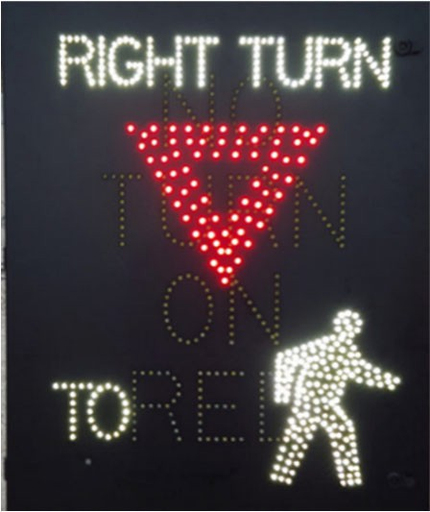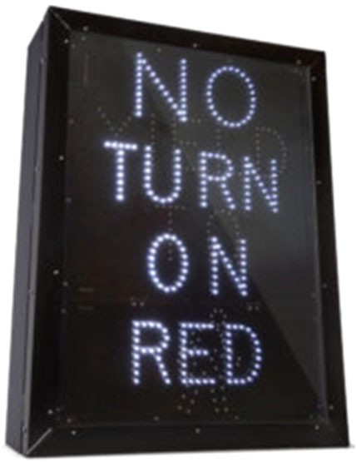

Table 3 – Allowable Treatments for Crosswalks
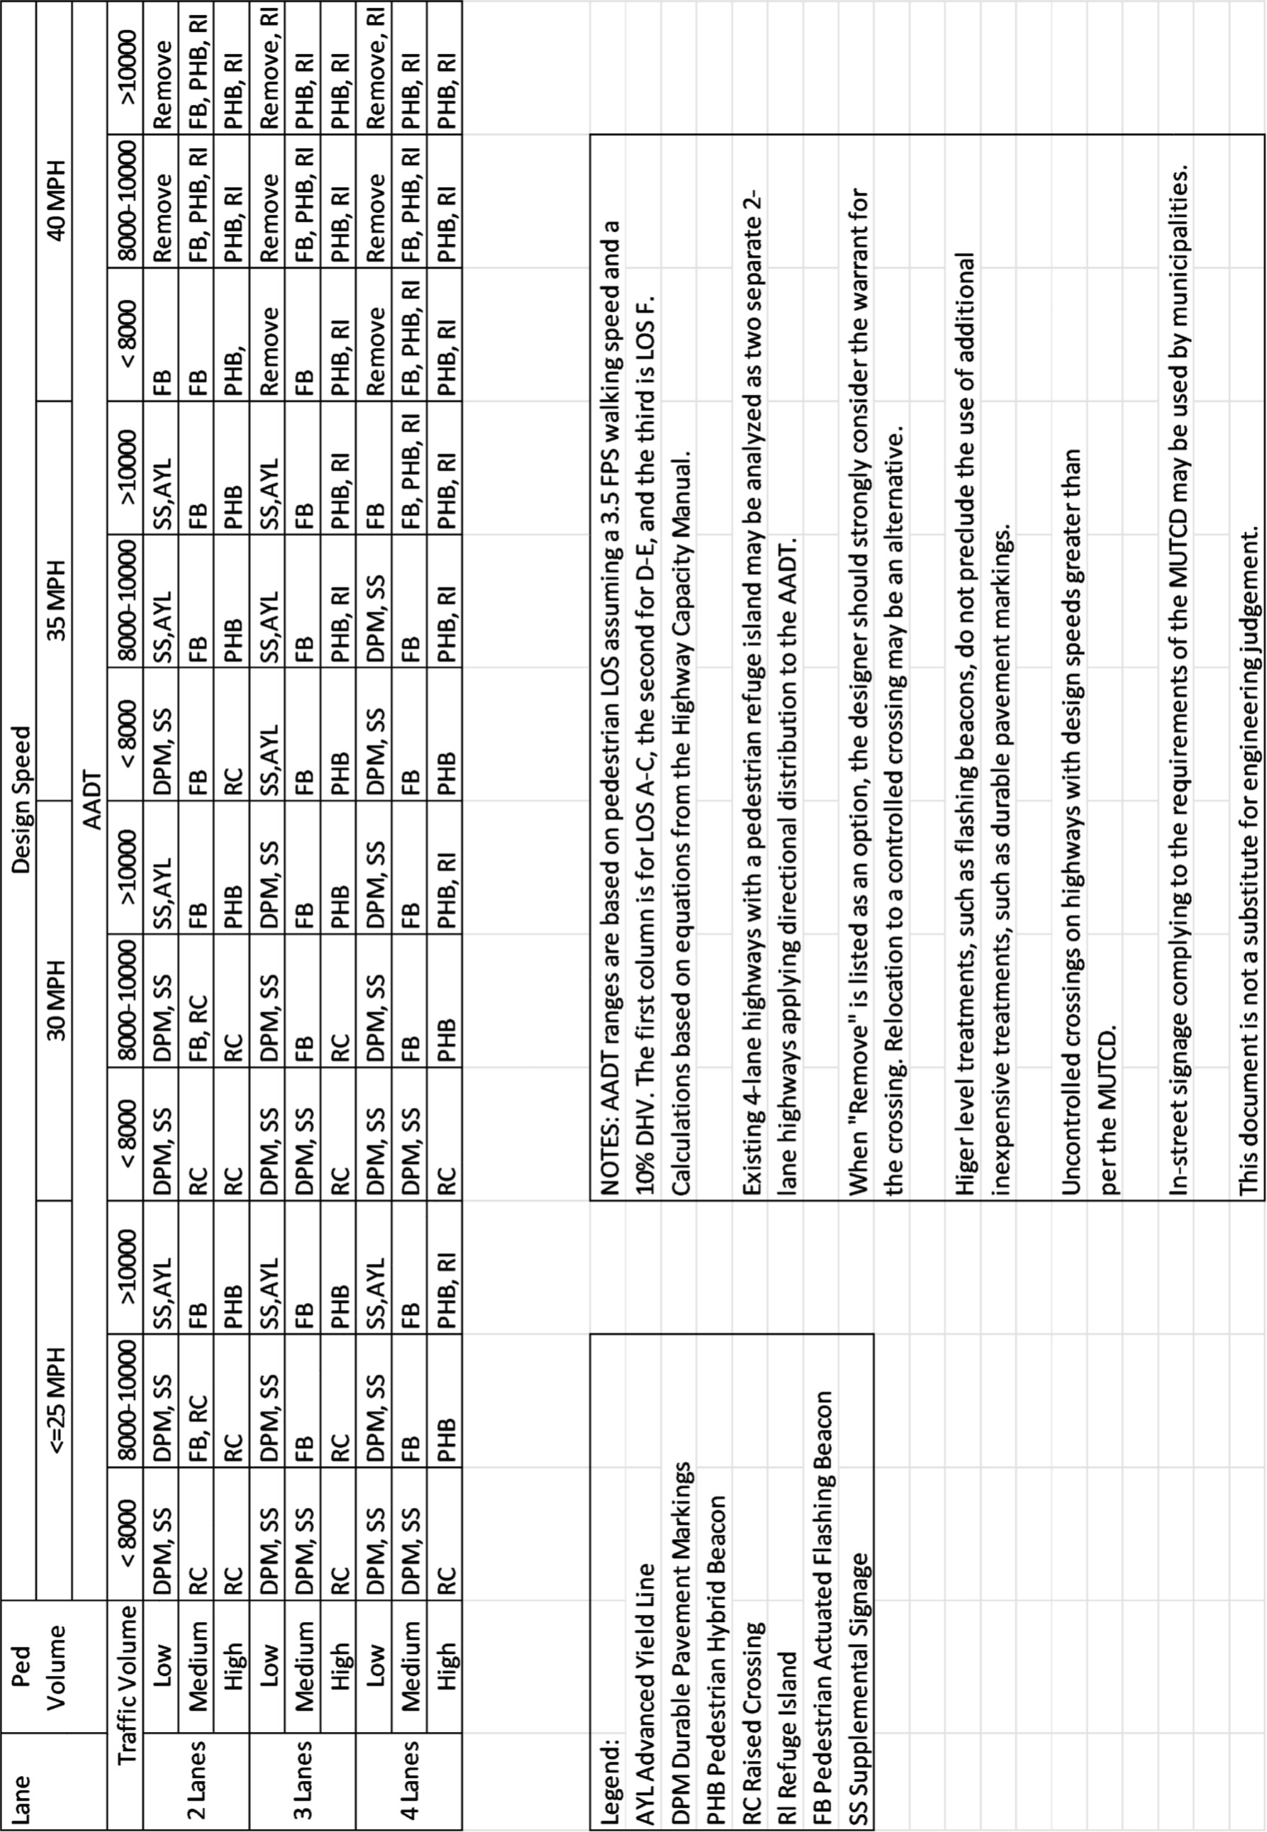

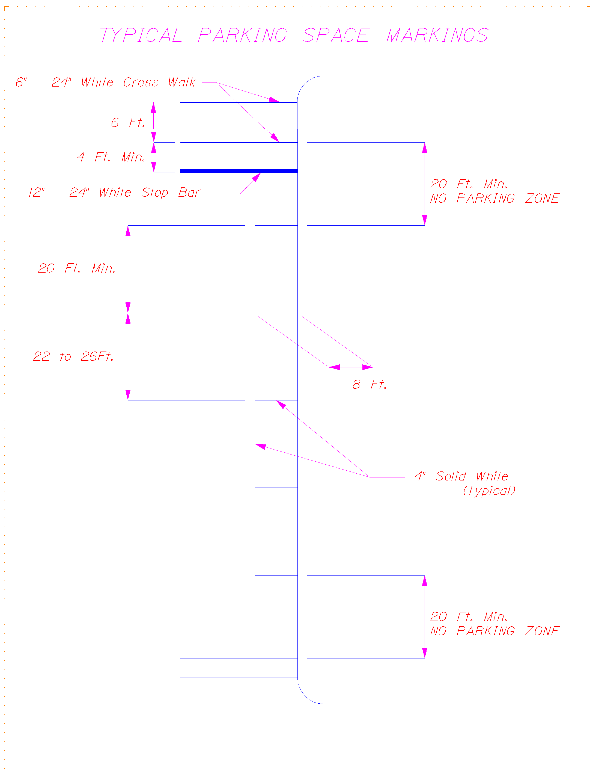

*30 Ft. Min No Parking Zone At a Traffic Signal

Figure 1

Parallel Lines
Zebra (Diagonal Markings)
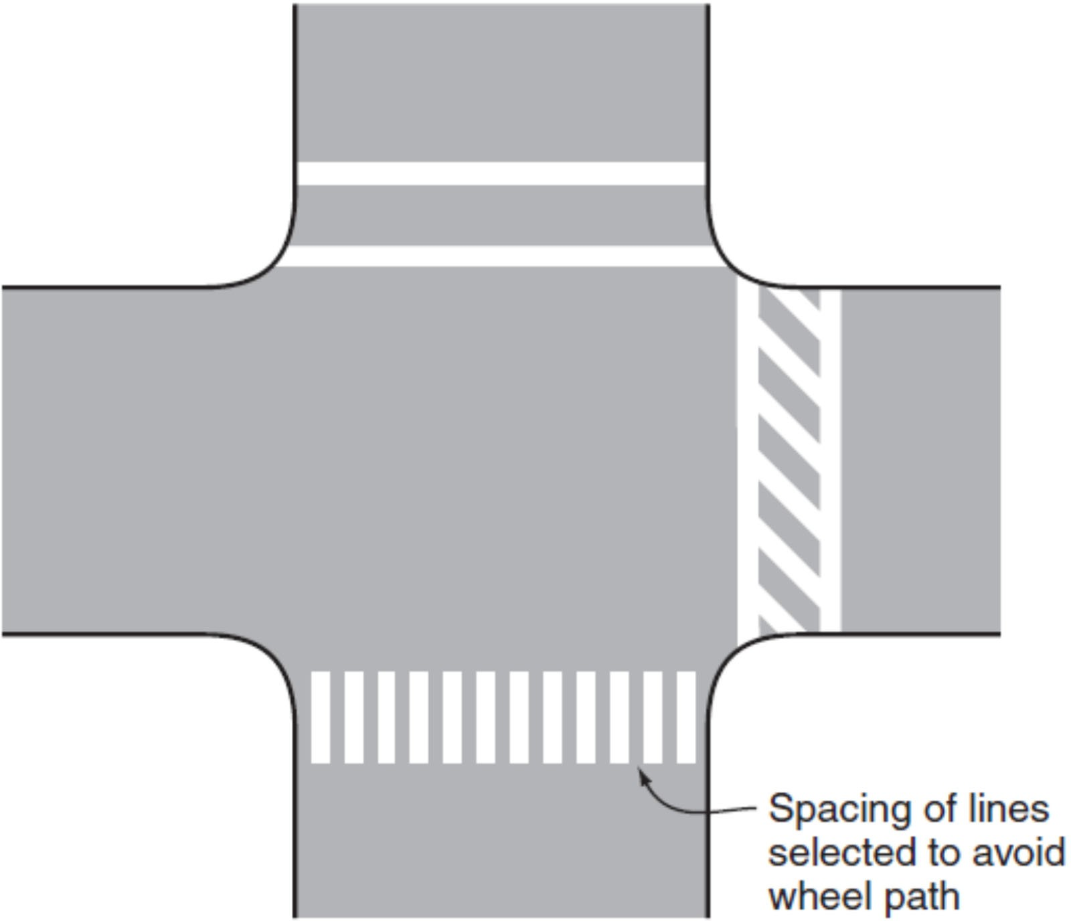

Figure 2
Continental (Piano Key Markings)

Figure 3 – Standard crosswalk signing uses both the W11-2 and W 16-7 P – Advanced assemblies use S1-1 and W 16-9 P
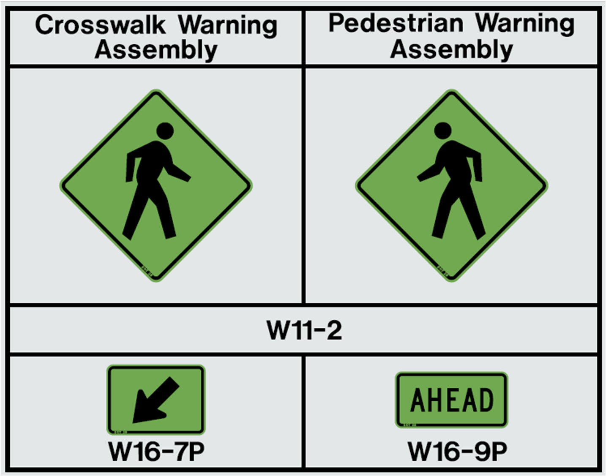
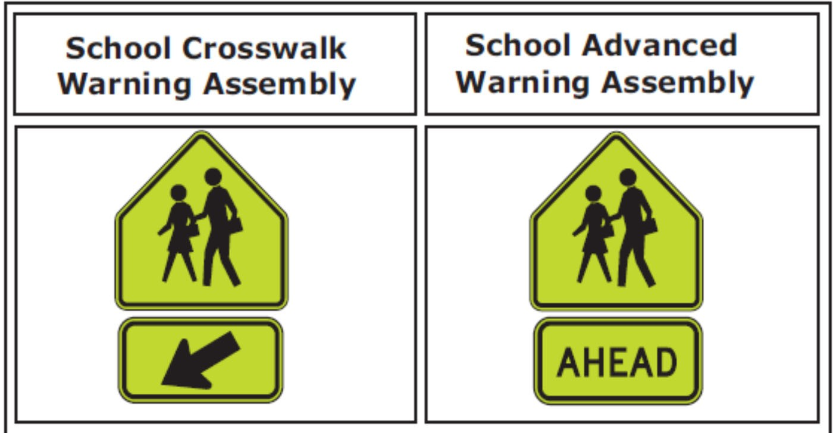
S1- 1
S1-1
W16-7P
W16-9P

Figure 4 - In-Street Pedestrian Signing
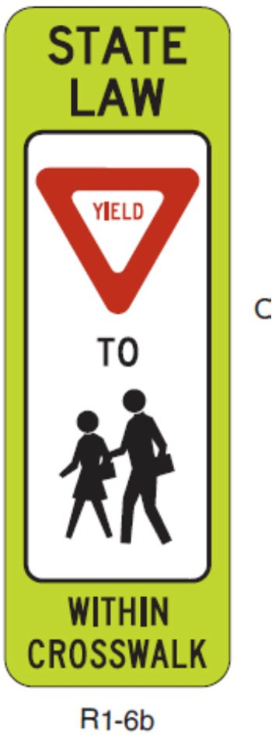
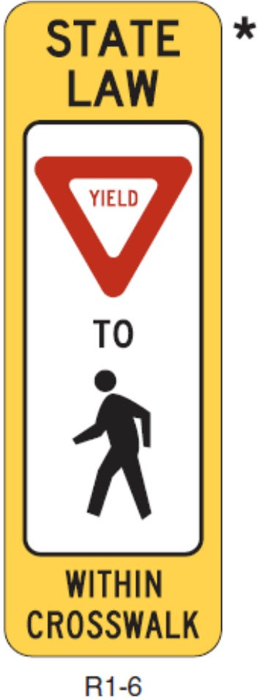

Figure 5 – Yield Bars and Associated Signage
